
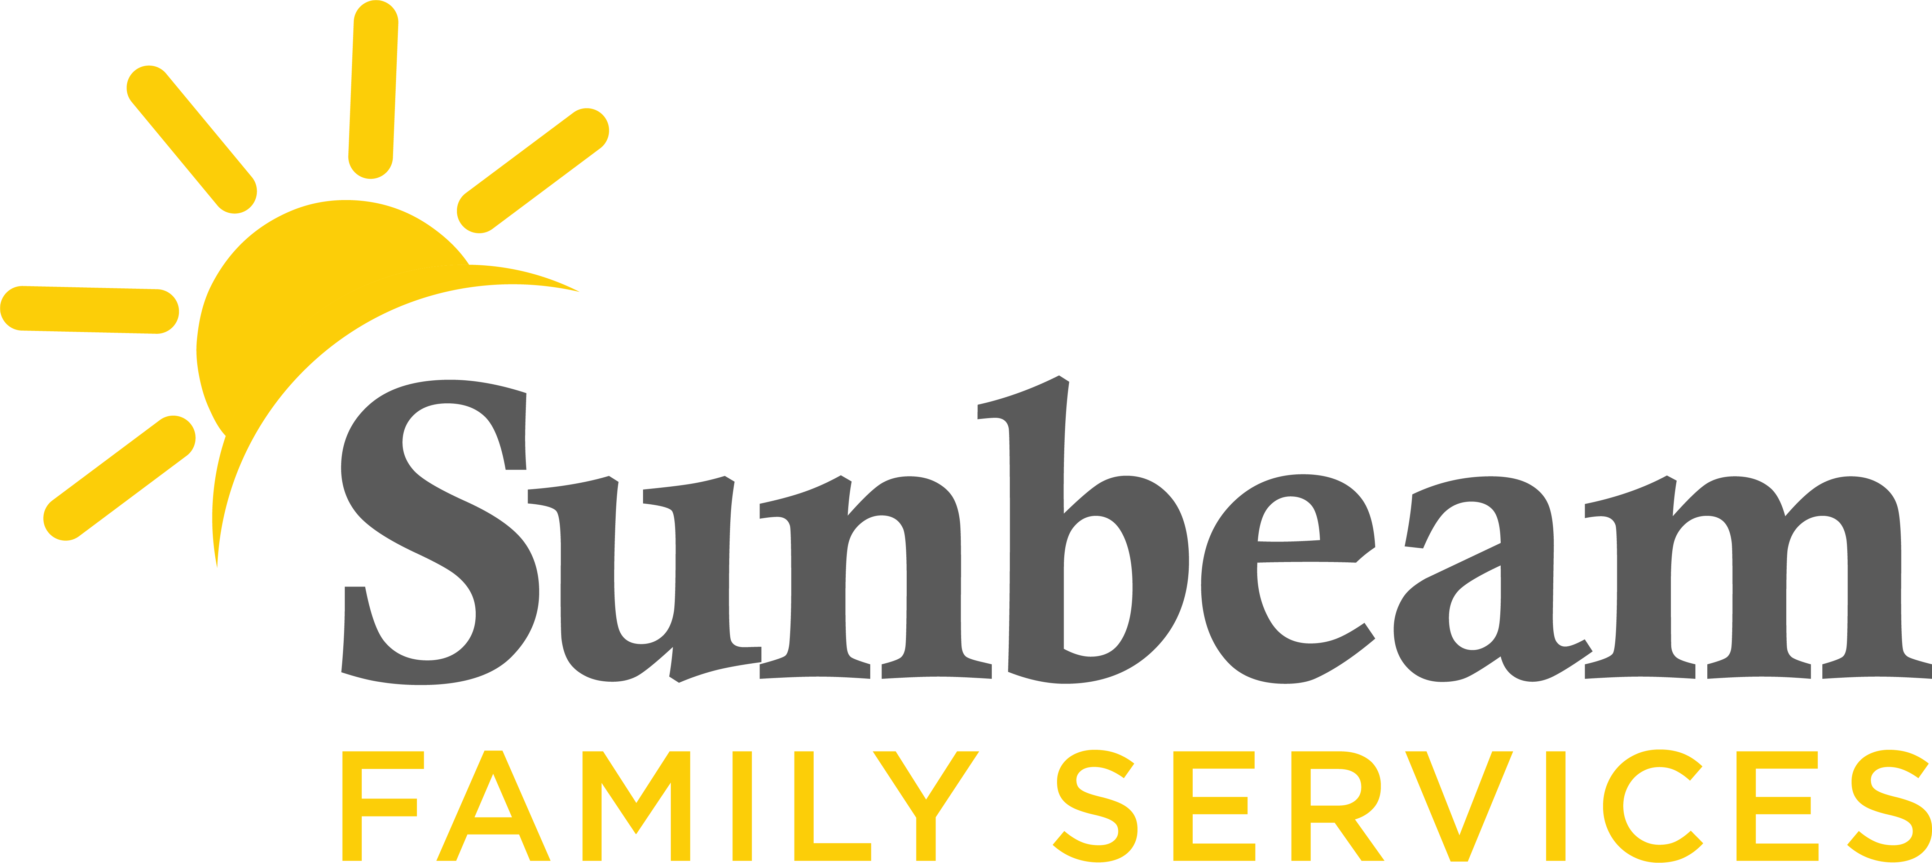
For Immediate Release
July 13, 2021
Contact:
Jeremy Coleman Marketing and Communications Manager
jcoleman@sunbeamfamilyservices.org
Office: (405) 609-1947 Mobile: (405) 202-5140

Sarah Mackey
WEOKIE Foundation Manager
sarahm@weokie.org
(405) 609-3530

WEOKIE Federal Credit Union Hosts Donation Match and Clothing Drive to Benefit Sunbeam Family Services
(OKLAHOMA CITY) – Through July 31, WEOKIE Federal Credit Union will match financial donations made to Sunbeam Family Services dollar for dollar, up to $2,500.
“We are thrilled to have the opportunity to give back to a wonderful organization like Sunbeam Family Services that provides resources to support children, families and seniors in the community,” said Sarah Mackey, manager of the WEOKIE Foundation.
During July, WEOKIE will also host a clothing drive to support babies and toddlers in Sunbeam's Early Education Centers. The organization invites the community to donate brand new items for babies and toddlers from birth to age 3. Most needed items include shoes, clothes, rain boots, socks, underwear, diapers and pull-ups.
“We are grateful for WEOKIE Federal Credit Union’s partnership and generosity,” said Sunbeam CEO Sarah Rahhal, LCSW, IMH-E®. “Community donations from this match and clothing drive will help children and families learn, grow and thrive.”
With support from the community, Sunbeam serves nearly 8,000 Central Oklahomans each year. As the Early Head Start provider in Oklahoma City, Sunbeam prepares babies and toddlers for school and life success. The nonprofit also provides safe homes for children in foster care, helps grandchildren thrive and supports Oklahoman's mental health and well-being.
To make a donation, or learn more, visit sfsok.org/weokie or call (405) 609-2311. To learn more about WEOKIE, or for a list of drop off locations, visit weokie.org.

###
About Sunbeam Family Services
Founded in 1907, Sunbeam Family Services is one of Oklahoma’s longest-serving nonprofits. The nonprofit helps children, families and seniors learn, grow and thrive. To learn more, call (405) 528-7721, visit SFSOK.org or join the conversation on Facebook, Twitter and Instagram.
About WEOKIE Federal Credit Union
WEOKIE Federal Credit Union empowers over 60,000 member-owners to make wise financial decisions, enabling them to keep more of their hard-earned money. Anyone that lives, works, worships, or attends school in the Oklahoma City metro area is eligible to become a member. WEOKIE Federal Credit Union cooperatively pools its members’ financial resources to help fellow Oklahomans. WEOKIE is a full-service financial institution with 12 metro locations that offers a full array of financial products and services.

