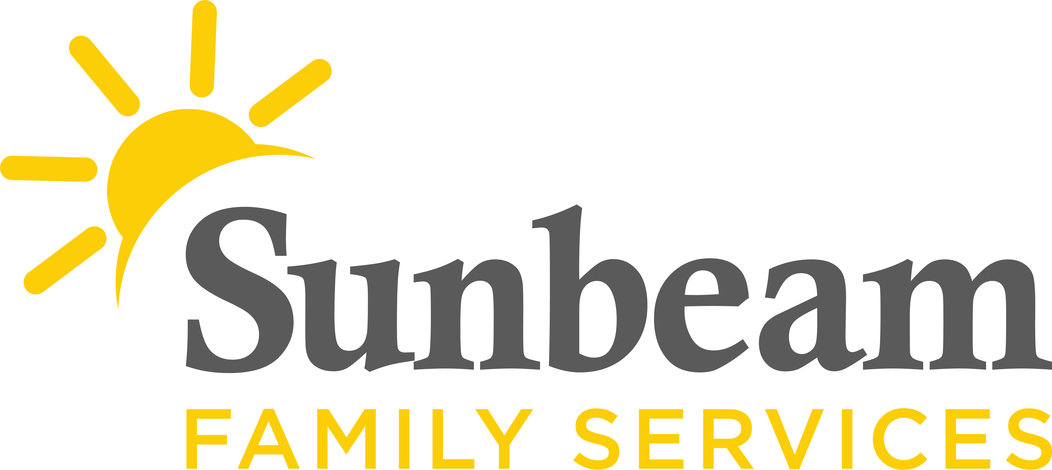
Download Sunbeam’s New Logo

FOR IMMEDIATE RELEASE:
Feb. 8, 2021

CONTACT:
Jeremy Coleman
Marketing and Communications Manager
jcoleman@sunbeamfamilyservices.org
405-609-1947 (O) | 405-202-5140 (M)

Sunbeam Family Services and Aetna Better Health Launch Trauma Informed Care Center of Excellence

(OKLAHOMA CITY) – Sunbeam Family Services is partnering with Aetna Better Health, the Medicaid managed care business of Aetna, and a CVS Health company, and University of Oklahoma’s Hope Research Center to launch the Trauma Informed Care Center of Excellence (Center) in Oklahoma City.
Aetna Better Health has long been a leader in the area of Trauma Informed Care by bringing together professionals and experts across the nation who understand the public health emergency that has emerged with the science of Adverse Childhood Experiences (ACEs), revealing the impact of ACEs on a person’s lifelong health. Through the Center, Aetna will expand its model to promote organizational culture change by coaching community partners, like Sunbeam, to address secondary trauma in the workforce and take care of those who take care of others.
“Studies show that between 6 and 26 percent of therapists working with traumatized populations are at risk of secondary trauma,” said Debra Bacon, chief operating office, Aetna Medicaid. “As a managed care organization, we are in a unique position to bring the science of trauma, as well as the science of hope, to bear on behalf of our members, our communities, our own staff and community workforce.”
The Center will offer resources to communities, including a learning collaborative, manual for organizations to implement trauma informed care practices in their workplace, and a lifeline to experts in the field for ongoing and sustained growth.
During the first phase of the project, Aetna will sponsor a year-long investigation designed, conducted and evaluated by the University of Oklahoma’s Hope Research Center in partnership with Sunbeam. Hope Research Center’s Executive Director Chan Hellman, PhD, will lead the project and train Sunbeam staff on the science of hope, which can mitigate the effects of secondary traumatic stress.
“By bringing together Sunbeam and the Center, and through the science of hope training, we will be able to measure the impact of learnings and strategic initiatives an organization takes as they strive to take their Trauma Informed Care approach to the next level,” said Dr. Hellman, executive director, Hope Research Center. “A workforce that may be experiencing secondary trauma can have several negative outcomes including higher rates of burnout, higher rates of turnover and lower wellbeing scores. What our research shows, is that nurturing hope among staff can buffer these negative effects of secondary traumatic stress among staff.”
Sunbeam CEO Sarah Rahhal is thankful for the partnership.
“As Dr. Hellman has taught so many of us in Oklahoma, hope is grounded in science and is the best practice of overall well-being,” said Sunbeam CEO Sarah Rahhal, LCSW. “We are grateful for the opportunity to partner with Aetna and Dr. Hellman in our hope quest.”
Through the Center, Aetna will capture outcomes from the project and for other organizations and systems in Oklahoma to promote workforce wellness.
“We know that organizations that work in the multi-system youth space may have a workforce experiencing secondary trauma,” Bacon said. “Conversely, a workforce that has higher hope is assumed to experience better job satisfaction and wellness. And, workers who have high hope are workers who come to their jobs each day with renewed energy and focus, for the benefit of their children and families. These are the hypotheses we will test and report on in the future.”
Aetna will also operate Centers in Ohio and California. This model will extend to Nevada and other states in the coming months.
To learn more about this program visit SunbeamFamilyServices.org or call (405) 528-7721.
###

About Sunbeam Family Services
Founded in 1907, Sunbeam Family Services is one of Oklahoma’s longest-serving nonprofits. The nonprofit helps children, families and seniors learn, grow and thrive. To learn more, call (405) 528-7721, visit sunbeamfamilyservices.org, or join the conversation on Facebook, Twitter and Instagram.

About Aetna Medicaid
Aetna Medicaid Administrators LLC (Aetna Medicaid), a CVS Health business, has over 30 years of experience managing the care of the most medically vulnerable, using innovative approaches and a local presence in each market to achieve both successful health care results and effective cost outcomes. Aetna Medicaid has particular expertise serving high-need Medicaid members, including those who are dually eligible for Medicaid and Medicare. Currently, Aetna Medicaid owns and/or administers Medicaid managed health care plans under the names of Aetna Better Health and other affiliate names. Together, these plans serve approximately 2.6 million people in 15 states, including Arizona, California, Florida, Illinois, Kansas, Kentucky, Louisiana, Maryland, Michigan, New Jersey, New York, Pennsylvania, Virginia, West Virginia and Texas. For more information, see www.aetnabetterhealth.com.

