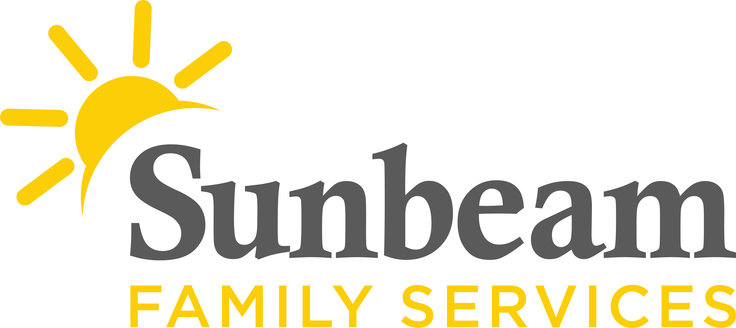
Download Sunbeam’s New Logo

FOR IMMEDIATE RELEASE:
Feb. 23, 2021

CONTACT:
Jeremy Coleman
Marketing and Communications Manager
jcoleman@sunbeamfamilyservices.org
405-609-1947 (O) | 405-202-5140 (M)

Sunbeam Awarded $25,000 from Kirkpatrick Family Fund
Grant Helps Children and Families Thrive

(OKLAHOMA CITY) – Sunbeam Family Services is pleased to announce it received a $25,000 grant from Kirkpatrick Family Fund.

“The Kirkpatrick Family Fund is pleased to support the many services provided by Sunbeam Family Services,” said Elizabeth Eickman, director of the Kirkpatrick Family Fund, “particularly its programs that support vulnerable seniors, families and foster youth. We appreciate Sunbeam and the critical role it plays in our community.”

This generous grant helps central Oklahoma children and families thrive.

“Kirkpatrick Family Fund’s partnership provides life-changing services to our neighbors,” said Sunbeam CEO Sarah Rahhal, LCSW. “With their support, children and families are connected to a caring team at Sunbeam.”

Learning begins long before a child starts kindergarten. As the Early Head Start provider in Oklahoma City, Sunbeam is a leader in early childhood education. With support from community partners and donors like Kirkpatrick Family Fund, Sunbeam’s early education centers and partner sites prepare young children from birth through age five to enter kindergarten with the skills necessary to be ready for school– and beyond.

Sunbeam is a traditional foster care agency providing temporary care and supportive services in a home environment for children in Canadian, Cleveland, Grady, Kingfisher, Lincoln, Logan, McClain and Oklahoma counties. As one of the 15 private foster care agencies in Oklahoma, Sunbeam works to improve the safety, well-being and permanency of children from birth to 18 years of age by recruiting and training new foster parents.

Since 1940, families have been supported through compassionate mental health services from a skilled team of mental health clinicians, which now includes the state's largest concentration of infant and early childhood mental health specialists.

Sunbeam also provides care and support for senior families through volunteer opportunities to serve seniors, support groups for caregivers and grandparents who are raising their grandchildren and respite for caregivers. This program encourages independence, self-sufficiency and aging in place by helping Oklahoma seniors stay active in their lives and connected to their communities.

Founded in 1907, Sunbeam Family Services is one of Oklahoma’s longest-serving nonprofits. To learn more, or make a donation, Sunbeam visit SunbeamFamilyServices.org or call (405) 528-7721.
###

About Sunbeam Family Services
Founded in 1907, Sunbeam Family Services is one of Oklahoma’s longest-serving nonprofits. The nonprofit helps children, families and seniors learn, grow and thrive. To learn more, call (405) 528-7721, visit sunbeamfamilyservices.org, or join the conversation on Facebook, Twitter and Instagram.

