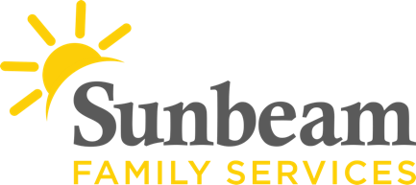
Download Sunbeam’s New Logo

For Immediate Release
April 28, 2021
Contact
Jeremy Coleman
Marketing and Communications Manager
jcoleman@sunbeamfamilyservices.org
Office: (405) 609-1947 Mobile: (405) 202-5140
There’s Still Time to Support Seniors Through $20,000 Donation Match
Benefits Sunbeam’s Senior Services Program
(OKLAHOMA CITY) - There’s still time to help Sunbeam Family Services support seniors. Through May 15, donations made to Sunbeam's Senior Services program will be matched dollar for dollar, up to $20,000. This generous match challenge is made possible thanks to Anderson Charitable Foundation.
Sunbeam’s Senior Services program supports self-sufficiency, encourages independence and helps Oklahoma seniors age in place and stay connected to our community. This also includes grandparents like Charla, who is raising her grandchildren with her husband.
“We connected with Sunbeam’s grandparents raising grandchildren services when things started falling apart,” shared Charla. “In the beginning of the pandemic, we felt terribly isolated. Now, we attend a support group every week and no longer feel alone.”
Oklahoma is one of the top states in the nation for the number of grandparents who are raising their grandchildren.
“We are inspired by everyday superheroes like Charla and Michael, who are raising their 3- and 4-year-old grandsons,” said Sunbeam CEO Sarah Rahhal LCSW, IMH-E®. “Please give what you can to help meet our goal of raising $20,000 by April 30 for Sunbeam’s Senior Services program.”
To make a donation to support seniors, visit sfsok.org/superhero or call (405) 609-2311.
###

About Sunbeam Family Services
Founded in 1907, Sunbeam Family Services is one of Oklahoma’s longest-serving nonprofits. The nonprofit helps children, families and seniors learn, grow and thrive. To learn more, call (405) 528-7721, visit sunbeamfamilyservices.org, or join the conversation on Facebook, Twitter and Instagram.

