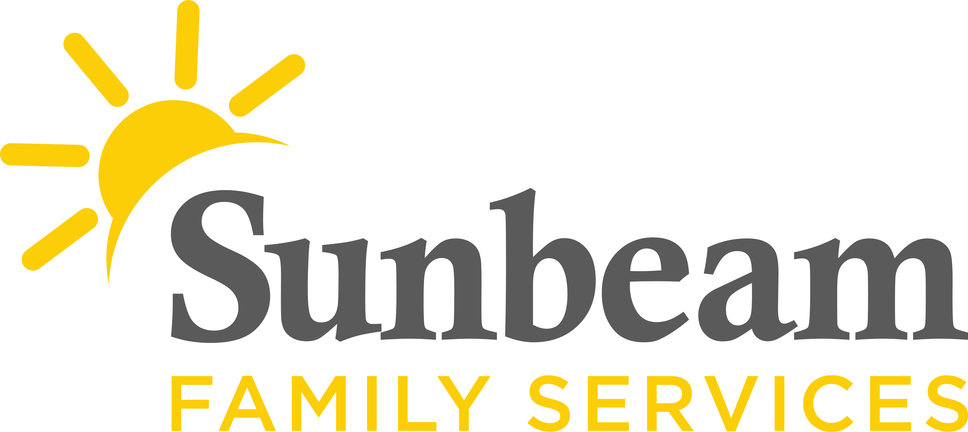
Download Sunbeam’s New Logo

FOR IMMEDIATE RELEASE:
Feb. 9, 2021

CONTACT:
Jeremy Coleman
Marketing and Communications Manager
jcoleman@sunbeamfamilyservices.org
405-609-1947 (O) | 405-202-5140 (M)

100 Volunteers Needed to Support Seniors
Sunbeam Launches New Senior Volunteer Engagement Program

(OKLAHOMA CITY) – Oklahomans 16 and older can help support seniors in the community by becoming a Senior Engagement Volunteer. Sunbeam Family Services is looking for 100 volunteers to donate their time and talents to join the nonprofit’s Senior Engagement Program.

The Senior Volunteer Engagement Program encourages independence and self-sufficiency by helping Oklahoma seniors stay active in their lives, connects them to their communities and supports aging in place.
“If you are looking for a way to volunteer and give back to our community during the pandemic, and help seniors, this opportunity is for you!” said Melva Franklin, senior volunteer engagement coordinator with Sunbeam.
As part of this program volunteers donate at least 1.5 hours per week and are partnered with a senior, who is vulnerable due to illness or age. Through their placement, volunteers provide companionship through activities like watching a movie or working on puzzles. Volunteers may also provide respite care to their partner’s caregiver and provide task assistance like meal preparation.
To learn more about this volunteer opportunity visit SunbeamFamilyServices.org/volunteer or call (405) 609-8930.
###

About Sunbeam Family Services
Founded in 1907, Sunbeam Family Services is one of Oklahoma’s longest-serving nonprofits. The nonprofit helps children, families and seniors learn, grow and thrive. To learn more, call (405) 528-7721, visit sunbeamfamilyservices.org, or join the conversation on Facebook, Twitter and Instagram.

