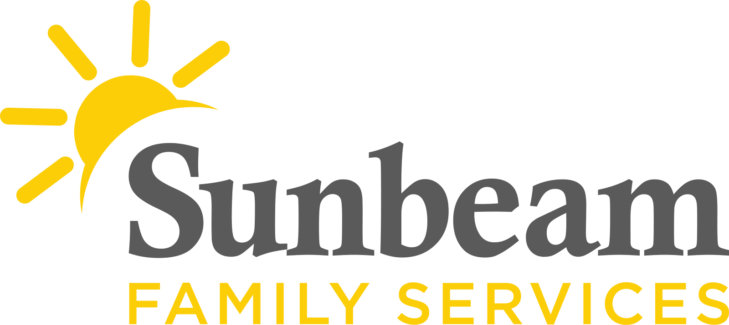
Download Sunbeam’s New Logo

FOR IMMEDIATE RELEASE:
April 16, 2021
CONTACT:
Jeremy Coleman
Marketing and Communications Manager
jcoleman@sunbeamfamilyservices.org
405-609-1947 (O) | 405-202-5140 (M)

Donations Matched Through May 15 to Support Seniors and their Families
Benefits Sunbeam’s Senior Services Program
(OKLAHOMA CITY) - Sunbeam Family Services invites the community to join them in supporting Oklahoma seniors. Through May 15, donations made to Sunbeam have double the impact for seniors and their families, thanks to a generous matching grant from Anderson Charitable Foundation. Donations will be matched dollar for dollar, up to $20,000, to provide resources and assistance to grandparents raising their grandchildren and caregivers.
"Oklahoma has one of the highest rates in the nation of grandparents who are raising their grandchildren. There are so many Oklahoma seniors who need your help, which is why your partnership matters. With your support, and the generous grant from Anderson Charitable Foundation, we can continue providing support groups for grandparents, respite for caregivers and help grandparents who are raising their grandchildren,” said Sunbeam CEO Sarah Rahhal LCSW, IMH-E®.
To make a donation to support seniors, visit sfsok.org/superhero or call (405) 609-2311.
###

About Sunbeam Family Services
Founded in 1907, Sunbeam Family Services is one of Oklahoma’s longest-serving nonprofits. The nonprofit helps children, families and seniors learn, grow and thrive. To learn more, call (405) 528-7721, visit sunbeamfamilyservices.org, or join the conversation on Facebook, Twitter and Instagram.

