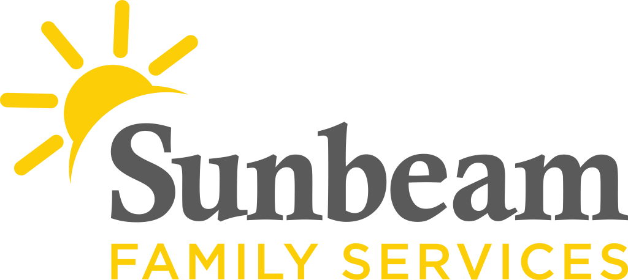

FOR IMMEDIATE RELEASE:
Jan. 7, 2021

CONTACT:
Jeremy Coleman
Marketing and Communications Manager
Jcoleman@sunbeamfamilyservices.org
Office: (405) 609-1947 Cell: (405) 202-5140

View this video about Sunbeam’s early education centers
Download photos of Sunbeam’s early education centers

Sunbeam Enrolling Infants and Toddlers in Free Child Care
Income Eligible
Sunbeam’s Early Education Centers are Open to Families Who Qualify

(OKLAHOMA CITY) – Sunbeam Family Services is enrolling infants and toddlers at its early education centers, which provide full-day, full-year services. Early Head Start at Sunbeam’s early education centers are like daycare, but offers additional benefits to children and families.

“Your children deserve the best,” said Paula Gates, chief program officer, early childhood services at Sunbeam. “Sunbeam is a leader in early childhood education. As the Early Head Start provider for central Oklahoma, we offer a low teacher-child ratio where children are able to receive more personalized attention from highly-educated staff. Our centers are open and are here to serve your family.”

Sunbeam is committed to helping children develop strong social skills, including self-confidence, and emerge better prepared for kindergarten. In addition to high-quality early education services, children enjoy free healthy snacks and meals. Children also receive free physical and dental examinations, immunizations, health screenings and any necessary follow-up services. Families also receive bus vouchers to support their transportation needs.

Sunbeam’s early education centers, as well as Sunbeam’s Home Visitation Program, are enrolling children from birth to age three. This free program is open to children who qualify for Department of Human Services (DHS) subsidy; children from families who receive public assistance, such as Temporary Assistance for Needy Families (TANF); children with disabilities; children in foster care, regardless of income; children from families with incomes below the poverty guidelines; children being raised by their grandparents; children from families experiencing homelessness; and pregnant women.

Enroll online at sunbeamfamilyservices.org/enroll. For more information email enroll@sunbeamfamilyservices.org or call (405) 609-3308.

###

About Sunbeam Family Services
Founded in 1907, Sunbeam Family Services is one of Oklahoma’s longest serving nonprofits. The nonprofit helps children, families and seniors learn, grow and thrive. To learn more, call (405) 528-7721, visit sunbeamfamilyservices.org, or join the conversation on Facebook, Twitter and Instagram.

