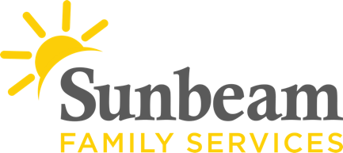
Download Sunbeam’s New Logo

For Immediate Release
May 5, 2021
Contact
Jeremy Coleman
Marketing and Communications Manager
jcoleman@sunbeamfamilyservices.org
Office: (405) 609-1947 Mobile: (405) 202-5140

May 6 is National Children's Mental Health Awareness Day
Skydance Bridge Turns Green
(OKLAHOMA CITY) – Tomorrow, the Skydance Bridge will turn green in honor of National Children's Mental Health Awareness Day. Each year, this day raises awareness about the importance of children's mental health and shows that positive mental health is essential to a child's healthy development.
Brains develop 90 percent of all neural connections by age three. Early life experiences and relationships with caregivers matter. The experiences of infants and young children, good or bad, have a long-lasting impact on health and well-being into adulthood. A nurturing, caregiving relationship with at least one adult can help buffer the impact of adversity in the earliest years.
Babies and young children can't wait until they're older for their mental health needs to be addressed. The time is now for us to speak for them and we know how. Sunbeam is committed to supporting the mental health and well-being of Oklahoma infants, young children, and their caregivers.
Sunbeam is one of the only organizations in central Oklahoma with a specialization in Infant and Early Childhood Mental Health. Services are provided along a continuum of promotion, prevention, and treatment to support relationships between young children, prenatally to age five, and their caregivers.
Supporting the earliest relationships helps mitigate the impact of adversity and reduces the likelihood of needing more intensive and costly interventions later, which can result when mental health concerns go unaddressed in the earliest years. Mental illness, substance use, domestic violence, and chronic health issues can be mitigated as a result of nurturing caregiving relationships early in life.
For more information visit SunbeamFamilyServices.org or call (405) 528-7721.
###
About Sunbeam Family Services
Founded in 1907, Sunbeam Family Services is one of Oklahoma’s longest-serving nonprofits. The nonprofit helps children, families and seniors learn, grow and thrive. To learn more, call (405) 528-7721, visit sunbeamfamilyservices.org, or join the conversation on Facebook, Twitter and Instagram.

