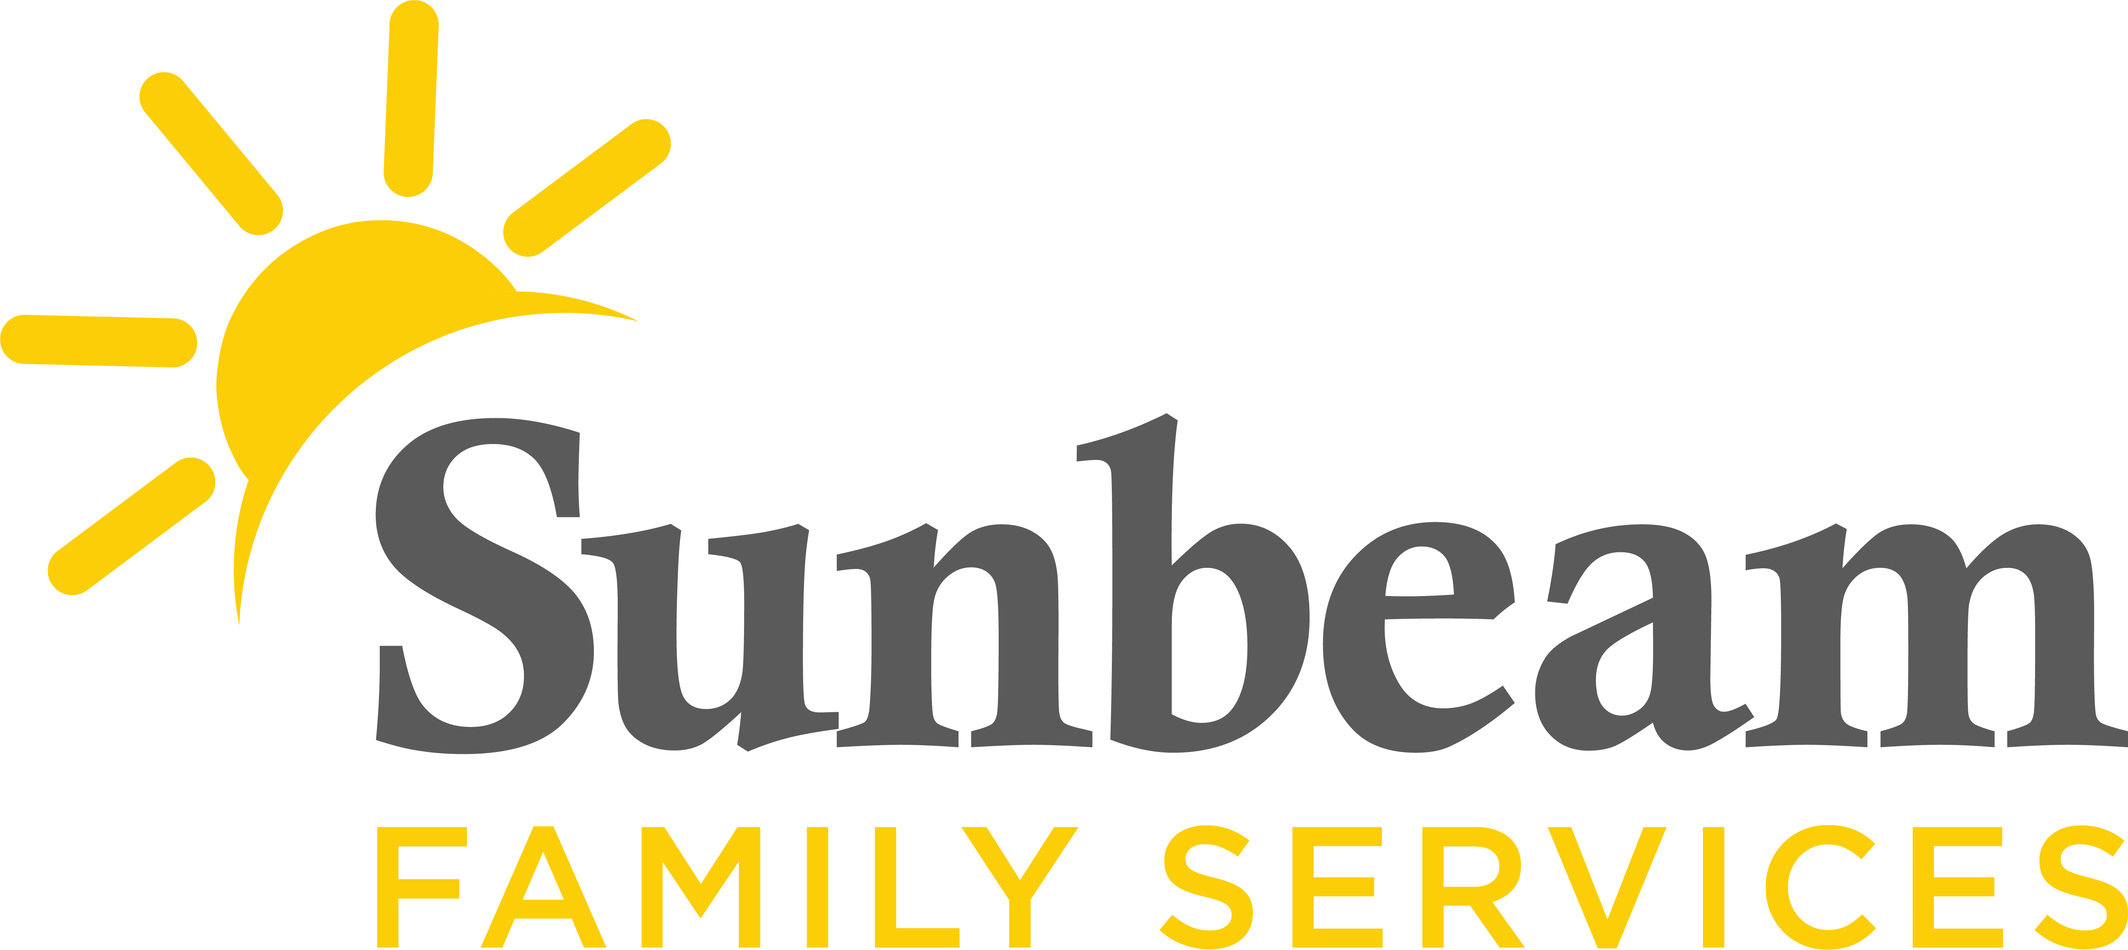
Download Sunbeam’s New Logo

FOR IMMEDIATE RELEASE:
May X, 2021

CONTACT:
Jeremy Coleman
Marketing and Communications Manager
jcoleman@sunbeamfamilyservices.org
405-609-1947 (O) | 405-202-5140 (M)

Download Photos of Sunbeam’s Hope Training.

Sunbeam and Aetna Partner with Dr. Chan Hellman on Science-Based Project to Measure Hope, Workforce Wellness

(OKLAHOMA CITY) – Sunbeam Family Services is partnering with Aetna Better Health, the Medicaid managed care business of Aetna, and Dr. Chan M. Hellman to measure hope and workforce wellness at Sunbeam. Hope is the belief that tomorrow will be better than today and that people have the ability to make it so.
“Hope has emerged as a leading protective factor promoting well-being for children, adults and families experiencing adversity and stress,” said Dr. Hellman, professor at the Anne & Henry Zarrow School of Social Work and executive director of Hope Research Center University of Oklahoma – Tulsa. “Moreover, we have found that nurturing hope among staff buffers against stress and burnout as they continue to serve our communities. Based upon the robust body of evidence, Sunbeam has committed to building a hope-centered agency where both clients and staff can thrive.”
This project will contribute to this understanding of hope by conducting an investigation that includes a baseline measurement of staff well-being, burnout, resilience and hope.
The leadership team at Sunbeam recently received training on the science and power of hope in their own lives. As part of the training, the team learned simple and effective strategies for hope-centered goal setting and pathways development. At the end of the training, leaders walked away with a foundational understanding on the science of hope and its connection to well-being.
Sunbeam is currently working on its organizational vision statement that will guide the future implementation of hope-centered, trauma-informed policies, practices and procedures.
“As Dr. Hellman has taught so many of us in Oklahoma, hope is grounded in science and is the best predictor of overall well-being,” said Sunbeam CEO Sarah Rahhal, LCSW. “The focus on hope is essential to the compassionate work our employees do every day. We are grateful for the opportunity to partner with Aetna and Dr. Hellman in our Hope Quest initiative.”
As part of Sunbeam’s Hope Quest, the nonprofit's staff will receive hope-centered trauma informed training. Some staff members will participate in Dr. Hellman’s Hope Navigator training, which will equip Sunbeam with Hope Ambassadors who will sustain and grow the work.
This initiative builds on the science of hope movement as a mechanism for advancing Trauma-Informed Care. Dr. Hellman’s research is focused on the application of Hope Theory to predict adaptive behaviors, and hope as a psychological strength that buffers stress and adversity among those impacted by family violence and trauma. To learn more about this initiative, visit SunbeamFamilyServices.org or call (405) 528-7721.
###

About Sunbeam Family Services
Founded in 1907, Sunbeam Family Services is one of Oklahoma’s longest-serving nonprofits. The nonprofit helps children, families and seniors learn, grow and thrive. To learn more, call (405) 528-7721, visit sunbeamfamilyservices.org, or join the conversation on Facebook, Twitter and Instagram.

About Aetna Medicaid
Aetna Medicaid Administrators LLC (Aetna Medicaid), a CVS Health business, has over 30 years of experience managing the care of the most medically vulnerable, using innovative approaches and a local presence in each market to achieve both successful health care results and effective cost outcomes. Aetna Medicaid has particular expertise serving high-need Medicaid members, including those who are dually eligible for Medicaid and Medicare. Currently, Aetna Medicaid owns and/or administers Medicaid managed health care plans under the names of Aetna Better Health and other affiliate names. Together, these plans serve approximately 2.6 million people in 15 states, including Arizona, California, Florida, Illinois, Kansas, Kentucky, Louisiana, Maryland, Michigan, New Jersey, New York, Pennsylvania, Virginia, West Virginia and Texas. For more information, see www.aetnabetterhealth.com.

About Dr. Chan Hellman
Dr. Hellman joined the University of Oklahoma in 2002. He is a professor in the Anne & Henry Zarrow School of Social Work and Founding Director of the Hope Research Center. He also holds Adjunct Professor appointments in the OU College of Public Health and School of Community Medicine.
Dr. Hellman’s current research is focused on the application of hope theory to predict adaptive behaviors and hope as a psychological strength that buffer stress and adversity among those impacted by family violence. In this context, he is also interested in the impact of prevention and intervention services on improving hope and well-being. Dr. Hellman has also begun to examine the effects of collective hope on a community’s capacity to thrive. He has numerous scholarly publications and books and has presented his research at both national and international conferences. Dr. Hellman teaches both the master’s and doctoral level primarily in the areas of positive psychology, research methods and statistics.

