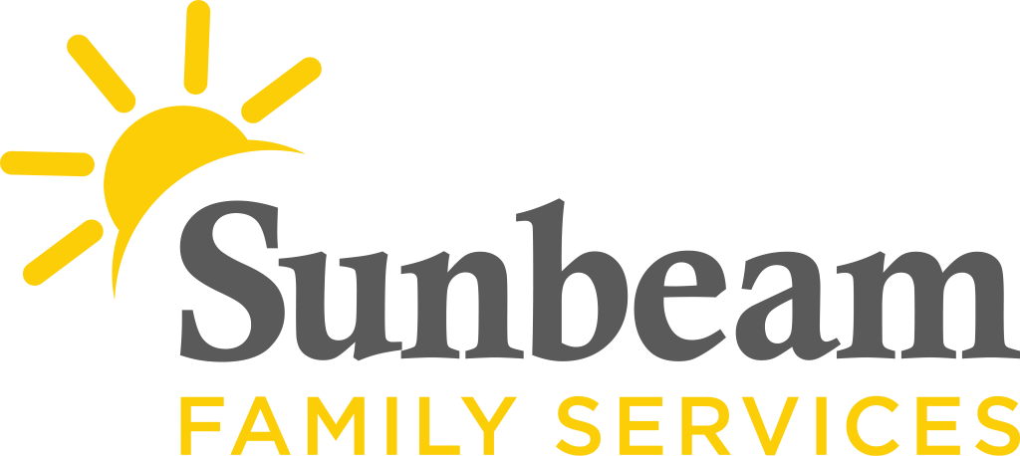

For Immediate Release
Dec. 14, 2020

Contact
Jeremy Coleman
Marketing and Communications Manager
jcoleman@sunbeamfamilyservices.org
Cell: (405) 202-5140 Office: (405) 609-1947

There’s Still Time to Empower Families This Year
Donation Match Supports Sunbeam Family Services, Community

(OKLAHOMA CITY) –There’s still to Sunbeam Family Services and empower families this holiday season. Through December 31, donations made to Sunbeam will be matched dollar for dollar, up to $25,000 – thanks to the McLaughlin Family Foundation.

Donations made to this match campaign help children, families and seniors across central Oklahoma through Sunbeam’s services. The nonprofit's programs support Oklahoman's mental health and well-being, prepare infants and toddlers for school and life success, provide safe fomes for children in foster care and help grandchildren thrive.

This includes grandparents like Laura and Alex, who are raising three grandchildren. Laura and Alex’s 2-year-old grandson, Connor, needed special attention. No matter what they did, Connor would cry and cling to Laura. He was also struggling with language development and couldn’t say a word. When Laura and Alex met the caring team at one of Sunbeam's early education centers, they immediately felt safe and at home.
Connor has attended one of Sunbeam’s early education center for three months and continues to blossom. He is excited to go school, has learned his colors and loves to talk about his friends. Laura and Alex are hopeful for Connor’s future.
“When I pick Connor up, the teacher greets us and hands us a progress report,” said Alex. “They care and it means a lot. Where he came from, and where he is today, it’s like night and day. It's hard for me not to cry.”
For more information, or to make a donation, visit SunbeamFamilyServices.org or call (405) 609-2311.

###
About Sunbeam Family Services
Founded in 1907, Sunbeam Family Services is one of Oklahoma’s longest serving nonprofits. The nonprofit helps children, families and seniors learn, grow and thrive. To learn more, call (405) 528-7721, visit sunbeamfamilyservices.org, or join the conversation on Facebook, Twitter and Instagram.

