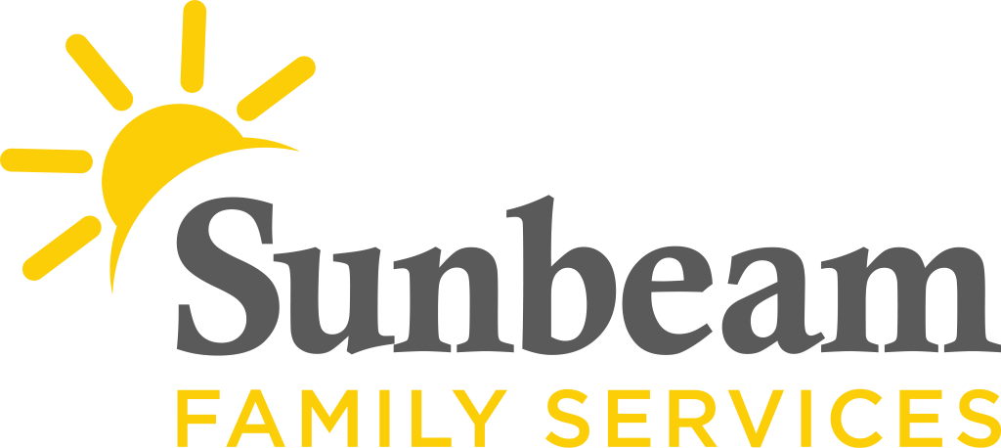

For Immediate Release
Dec. 21, 2020

Contact
Jeremy Coleman
Marketing and Communications Manager
jcoleman@sunbeamfamilyservices.org
Cell: (405) 202-5140 Office: (405) 609-1947

Bank of America Supports Sunbeam this Holiday Season
Donation Provides Holiday Help, Grant Offers Leadership Training

(Oklahoma City) — Thanks to a $2,500 donation from Bank of America, Sunbeam Family Services is able to provide holiday help to children, seniors and families who receive services from the nonprofit.

“Sunbeam Family Services is a pillar in our community,” said Tony Shinn, market president for Bank of America in Oklahoma City. “Through partnerships like the Neighborhood Champions program, Bank of America hopes to bolster the efforts of Sunbeam in the community and show our appreciation for the important roles that our nonprofit partners play in providing critical services.”

Last month, Sunbeam was awarded a $50,000 Neighborhood Champion grant from Bank of America for operational funding and leadership training. The Neighborhood Champions program supports the role strong nonprofit leaders play in advancing economic mobility, and it is a part of Bank of America’s commitment to investing in the long-term health of communities.

“Thank you, Bank of America!” said Sarah Rahhal, LCSW, chief executive officer of Sunbeam Family Services. “With your support, we are providing additional holiday help for our families who need it the most. We appreciate your partnership and are proud to be a Neighborhood Champion.”

For more information about Sunbeam, or to make a donation, visit SunbeamFamilyServices.org or call (405) 528-7721. Through December 31, donations made to Sunbeam will be matched dollar for dollar, up to $25,000 – thanks to the McLaughlin Family Foundation.

Sunbeam Family Services
Founded in 1907, Sunbeam Family Services is one of Oklahoma’s longest serving nonprofits. The nonprofit helps children, families and seniors learn, grow and thrive. To learn more, call (405) 528-7721, visit sunbeamfamilyservices.org, or join the conversation on Facebook, Twitter and Instagram.

Bank of America
At Bank of America, we’re guided by a common purpose to help make financial lives better, through the power of every connection. We’re delivering on this through responsible growth with a focus on our environmental, social and governance (ESG) leadership. ESG is embedded across our eight lines of business and reflects how we help fuel the global economy, build trust and credibility, and represent a company that people want to work for, invest in and do business with. It’s demonstrated in the inclusive and supportive workplace we create for our employees, the responsible products and services we offer our clients, and the impact we make around the world in helping local economies thrive. An important part of this work is forming strong partnerships with nonprofits and advocacy groups, such as community, consumer and environmental organizations, to bring together our collective networks and expertise to achieve greater impact. Learn more at about.bankofamerica.com, and connect with us on Twitter (@BofA_News).

For more Bank of America news, including dividend announcements and other important information, visit the Bank of America newsroom and register for email alerts.

www.bankofamerica.com

###

