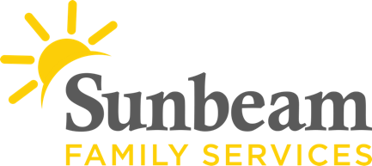|
Download Sunbeam’s New Logo

For Immediate Release
May 4, 2021
Contact
Jeremy Coleman
Marketing and Communications Manager
jcoleman@sunbeamfamilyservices.org
Office: (405) 609-1947 Mobile: (405) 202-5140
Applications Now Available for Grandparents who are Raising their Grandchildren to Receive Free Fall School Supplies
(OKLAHOMA CITY) – Sunbeam Family Services is once again providing free school supplies to grandparents, age 55 and older, who are raising their own grandchildren in the absence of parents in the home and live in Oklahoma, Cleveland, Canadian or Logan County. Applications for this program are due May 31 and the supplies will be distributed on July 24th.
The Grandparents Raising Grandchildren program at Sunbeam provides pre-qualified grandparents with school supplies for their grandchildren. This program helps eliminate the financial burden of back-to-school expenses and ensures their grandchildren are prepared for the upcoming school year. This year, 500 children will benefit from the school supply assistance program.
“Grandfamilies need support more than ever,” said Talena Ford, senior engagement project manager. “This year we will not only have school supplies in each backpack, but we will also provide resources that are current and applicable for each grandfamily.”
This program is made possible by Sunbeam, Areawide Aging Agency, Oklahoma City Police Department, Oklahoma County Sherrif’s Office and TRIAD.
For more information, or to apply for school supply assistance, visit sunbeamfamilyservices.org/GRG or call (405) 609-8812 for more information.
###
About Sunbeam Family Services
Founded in 1907, Sunbeam Family Services is one of Oklahoma’s longest-serving nonprofits. The nonprofit helps children, families and seniors learn, grow and thrive. To learn more, call (405) 528-7721, visit sunbeamfamilyservices.org, or join the conversation on Facebook, Twitter and Instagram.

About Sunbeam’s Caregiver Engagement Program
Provided by Sunbeam Family Services through a Title III Older Americans Act Grant from Areawide Aging Agency and community partners. The Caregiver Fundamentals Project makes no distinction on the grounds of race, color, gender, age, ancestry, national origin, religion, or disability. A portion of the project costs are met by state and federal Older Americans Act funds from Areawide Aging Agency and the Oklahoma Department of Human Services Aging Services Division. There are no costs to participants; however, donations are accepted. Suggested donation per service: Information Services, $1/activity; Access Assistance, $1/activity; Support Group, $2.50/meeting; Respite, $2.50/visit; School Supplies, $5/family; and Training Seminar, $5/seminar.

