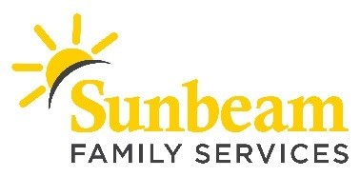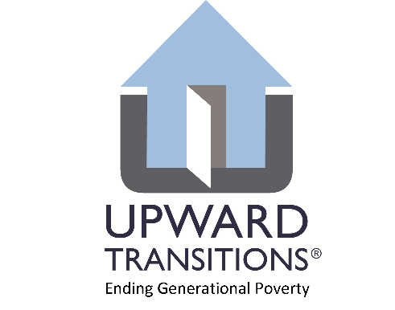
FOR IMMEDIATE RELEASE:
April 24, 2020

CONTACT:
Anne Peters
Sunbeam Family Services - Marketing and Communications Manager
apeters@sunbeamfamilyservices.org
(580) 231-1044 (c)

Angie Doss
Sunbeam Family Services - Chief External Relations Officer
adoss@sunbeamfamilyservices.org
(619) 347-4057 (c)

Micah James
Upward Transitions - Director of Development and Public Relations
mjames@upwardtransitions.org
(405) 694-1818 (c)

Sunbeam Partners with Upward Transitions to Support COVID-19 Relief
Lends Staff Members to Expedite and Facilitate Emergency Relief Payments
(OKLAHOMA CITY) – Year-round, Sunbeam Family Services partners with Upward Transitions to assist seniors who are experiencing homelessness and grandparents who are raising their grandchildren. During COVID-19, they’re expanding their collaboration to provide emergency relief to families and individuals who have lost income due to the impact of the COVID-19 crisis.
“Sunbeam is lending two staff members to assist Upward Transitions with facilitating emergency relief payments for rent and utilities to the community,” said Sarah Rahhal, LCSW, chief executive officer of Sunbeam. “We have always been strong proponents of community partnerships, and during these times partnerships become even more critical. Strengthening this partnership is a perfect example of recognizing the importance of working together to meet basic needs.”
Upward Transitions is able to provide emergency relief to the community thanks to the United Way of Central Oklahoma’s COVID-19 Response Fund. Upward Transitions received a grant of $110,000 through this fund and expects to help around 55 households with up to two months of past-due rent and utilities now through the end of May. To date, Upward Transitions has received over 150 requests for assistance, which will be screened on a first-come basis. The requirements to receive assistance can be found on the Upward Transitions website, www.upwardtransitions.org.
The United Way’s COVID-19 Response Fund is dedicated to increasing resilience among central Oklahoma’s most vulnerable individuals and families. This fund supports Partner Agencies of United Way of Central Oklahoma, United Way of Logan County and United Way of Canadian County. It is used to address the needs of those individuals who are experiencing hardship primarily due to temporary unemployment, lost income or unexpected expenses related and due to COVID-19.
“Sunbeam has been a valued partner of ours over the years, and they immediately came to mind when we began talking about distributing this assistance,” said Periann Pulliam, chief executive officer of Upward Transitions. “When I made the call to ask for help, Sarah didn’t hesitate to say yes. No single organization is able to tackle the enormity of this crisis, and Upward Transitions is grateful to have compassionate partners like Sunbeam.”
Sunbeam and Upward Transitions are proud United Way of Central Oklahoma partner agencies. For more information about Sunbeam visit SunbeamFamilyServices.org or call (405) 528-7721. To learn more about Upward Transitions, visit upwardtransitions.org or call (405) 232-5507.

###
About Sunbeam Family Services
Founded in 1907, Sunbeam Family Services is one of Oklahoma’s longest serving nonprofits and is one of the original United Way of Central Oklahoma Community partners. Sunbeam’s mission is to provide help, hope and the opportunity to succeed through Early Childhood, Counseling, Foster Care and Senior Services. To learn more, call 405-528-7721, visit sunbeamfamilyservices.org, or join the conversation on Facebook, Twitter and Instagram.

About Upward Transitions
Upward Transitions is an Oklahoma County non-profit that serves families and individuals who are homeless, at risk of becoming homeless, or stranded by providing case management and stabilizing resources to help meet basic social needs. To learn more about Upward Transitions, go to www.upwardtransitions.org or contact Micah James, Director of Development and Public Relations at 405-232-5507 or mjames@upwardtransitions.org.

