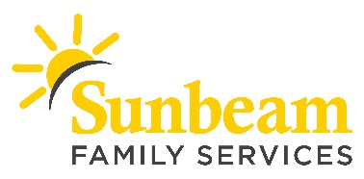
FOR IMMEDIATE RELEASE
Jan. 14, 2020

CONTACT
Angie Doss
Chief External Relations Officer
adoss@sunbeamfamilyservices.org
405-609-2311 (o) | 619-347-4057 (c)

Kendra Gives Back Event Jan. 16 to Benefit Sunbeam Family Services

(OKLAHOMA CITY) – Sunbeam Family Services is raising money for its programs that serve the community’s children, families and seniors through a partnership with Kendra Scott. On Thursday, Jan. 16 from 5 to 7 p.m., during their Kendra Gives Back event, the Classen Curve location will donate 20 percent of proceeds to Sunbeam. Patrons must mention Sunbeam Family Services at time of purchase.

”The Kendra Gives Back event is a great way for customers to shop while also helping individuals and families in our community,” said Sarah Rahhal, Sunbeam’s chief executive officer. “With your support, the future is bright for our Oklahoma neighbors.”

Kendra Scott is located at 5810 N. Classen Blvd. Those unable to attend in person may still show support by making a purchase over the phone during the event at (405) 241-4203.

Sunbeam’s mission is to provide people of all ages with help, hope and the opportunity to succeed through Early Childhood, Foster Care, Counseling and Senior Services programs. Each year, Sunbeam provides wraparound services to more than 10,500 Oklahomans to break the cycle of generational poverty and help them learn, grow, heal and thrive. To learn more about Sunbeam or make a donation, visit sunbeamfamilyservices.org or call (405) 528-7721.

###

About Sunbeam Family Services
Founded in 1907, Sunbeam Family Services is one of Oklahoma’s longest serving nonprofits and is one of the original United Way of Central Oklahoma Community partners. Sunbeam’s mission is to provide people of all ages with help, hope and the opportunity to succeed through Early Childhood, Foster Care, Counseling and Senior Services programs. To learn more, call (405) 528-7721, visit sunbeamfamilyservices.org, or join the conversation on Facebook, Twitter and Instagram.

