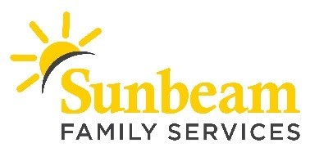
FOR IMMEDIATE RELEASE:
April 20, 2020

CONTACT:
Anne Peters
Marketing and Communications Manager
apeters@sunbeamfamilyservices.org
(580) 231-1044 (c)

Angie Doss
Chief External Relations Officer
adoss@sunbeamfamilyservices.org
(619) 347- 4057 (c)

April 21 is Give from Home Day
Sunbeam Invites Community to Support Essential Services During COVID-19

(OKLAHOMA CITY) – Sunbeam Family Services invites Oklahomans to participate in #GiveFromHomeDay on April 21, 2020. This giving day encourages the community to come together in supporting Oklahomans, and nonprofits like Sunbeam, during COVID-19.
“As an essential agency, Sunbeam continues providing services to our community, but we can’t do it alone,” said Sarah Rahhal, LCSW, chief executive officer of Sunbeam. “Our work together is far too important to stop during this time. One of our top priorities is ensuring the health and well-being of children, families, and seniors are being supported. Please consider making a donation, or shopping our Amazon wish list, to help our neighbors impacted during these uncertain times.”
Sunbeam is committed to serving Oklahomans during COVID-19, and beyond. The nonprofit is providing Telehealth mental health services, supporting caregivers and grandparents who are raising their grandchildren through video support groups, and helping young children and their families thrive through resources and one-on-one video support.
“No matter how long this pandemic goes on, we are here to support our community,” said Rahhal. “By taking care of ourselves and each other today, we are working together for a better tomorrow.”
To make a donation, or for more information, visit sunbeamfamilyservices.org or call (405) 609-2311.
###
About Sunbeam Family Services
Founded in 1907, Sunbeam Family Services is one of Oklahoma’s longest serving nonprofits and is one of the original United Way of Central Oklahoma Community partners. Sunbeam’s mission is to provide help, hope and the opportunity to succeed through Early Childhood, Counseling, Foster Care and Senior Services. To learn more, call (405) 528-7721, visit sunbeamfamilyservices.org, or join the conversation on Facebook, Twitter and Instagram.

