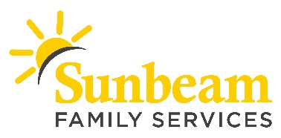
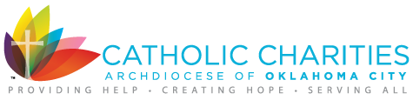

FOR IMMEDIATE RELEASE:
Nov. 19, 2018

CONTACT:
Angie Doss
Chief External Relations Officer
adoss@sunbeamfamilyservices.org
405-609-2311 (o) | 619-347-4057 (c)

Download a photo from A Very Giving Christmas 2018.

Help Spread Holiday Cheer, A Very Giving Christmas is Near
Sunbeam Family Services and Catholic Charities
Ask Community to Stock St. Nick’s Shoppe

(OKLAHOMA CITY) – Sunbeam Family Services and Catholic Charities Oklahoma City are asking the community to help stock St. Nick’s Shoppe for A Very Giving Christmas. Through this partnership, 500 Oklahoma City families will receive presents for under their Christmas Tree. Donations are needed through Dec. 7 to bring cheer to families this holiday season.

In total, 7,000 gifts are needed to stock St. Nick’s Shoppe. New, unwrapped gifts are needed for children of all ages. Most needed gifts include action figures, baby dolls and gift cards. Drop off locations include: Catholic Charities, participating Express Employment Professionals locations, KFOR, participating metro-area fire stations and Sunbeam Family Services. To view Santa’s wish list and for a complete list of drop off locations visit AVeryGivingChristmas.org or call 405-609-1755.

"Giving and service have always been the foundation to our culture at Express," said Bill Stoller, chief executive officer and chairman of the board for Express Employment Professionals International. "We know how important it is to support the communities where we work, serve and live. That is why we are proud to be a part of A Very Giving Christmas in collaboration with Catholic Charities."

As part of A Very Giving Christmas, Sunbeam will host St. Nick’s Shoppe from Dec. 12 through 15. Families served by Catholic Charities and Sunbeam are invited to shop for toys and other gifts to place under their Christmas tree.

Volunteer opportunities are also available and include greeting families, helping families select their gifts or wrapping gifts. Volunteers must be at least 10 years old. Spanish-speaking volunteers are also needed to help families shop.

A Very Giving Christmas is sponsored by Express Employment Professionals, KFOR and Tyler Media.

###

About Sunbeam Family Services
Sunbeam helps children, families and seniors learn, grow, heal and thrive. Founded in 1907, Sunbeam Family Services is one of Oklahoma’s longest serving nonprofits, providing help, hope and the opportunity to succeed to people of all ages and all stages of life in central Oklahoma through Early Childhood, Counseling, Foster Care and Senior Services. To learn more, call 405-528-7721, visit sunbeamfamilyservices.org, or follow them on Facebook, Twitter and Instagram.

About Catholic Charities of the Archdiocese of Oklahoma City
Guided by Catholic teaching, Catholic Charities of the Archdiocese of Oklahoma City serves those in need, regardless of their faith, through transformative, empowering and dignity-affirming social service programs that seek to eliminate material, emotional and spiritual poverty across Central and Western Oklahoma. To learn more, call 405-523-3000, visit ccaokc.org, or follow them on Facebook, Twitter and Instagram.

