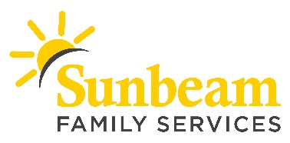
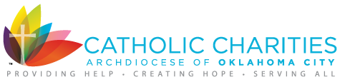

FOR IMMEDIATE RELEASE:
Oct. 29, 2018

CONTACT:
Angie Doss
Chief External Relations Officer
adoss@sunbeamfamilyservices.org
405-609-2311 (o) | 619-347-4057 (c)

Download a photo from A Very Giving Christmas 2018.

Volunteers and 7,000 Gifts Needed to
Spread Holiday Cheer to OKC Families This December
Sunbeam Family Services and Catholic Charities OKC Stock
the Shelves for A Very Giving Christmas

(OKLAHOMA CITY) – Sunbeam Family Services and Catholic Charities Oklahoma City are once again partnering together to bring holiday cheer to 500 Oklahoma City families through A Very Giving Christmas. The nonprofits are turning to the community to fill volunteer shifts and provide 7,000 gifts to stock their shelves in preparation for the holiday festivities this December.

As part of A Very Giving Christmas, Sunbeam will host St. Nick’s Shoppe from Dec. 12 through 15. Families served by Catholic Charities and Sunbeam are invited to shop for toys and other gifts to place under their Christmas tree at no cost.

New, unwrapped gifts are needed for children of all ages. Most needed gifts include action figures, baby dolls and gift cards. To learn more about signing your business or organization to collect donations visit AVeryGivingChristmas.com or contact Jane at jmeeks@sunbeamfamilyservices.org or 405-609-1755.

Volunteer opportunities for individuals, families and groups are also available and include decorating St. Nick’s Shoppe, greeting families, helping families select their gifts or wrapping gifts. Volunteers must be at least 10 years old. Spanish-speaking volunteers are also needed to help families shop.

“Donors and volunteers create a warm, festive and joyful shopping experience for families who are financially unable to purchase presents for their family,” said Jim Priest, chief executive officer of Sunbeam. “We are honored to serve families through this partnership with Catholic Charities, as well as support from donors and volunteers in the community.”

The A Very Giving Christmas is a collaboration born on the corridor of hope. It’s a simple philosophy: complete the giving cycle, encourage empowerment, and the entire community benefits.

“Our partnership with Sunbeam Family Services reflects the partnership we foster among our donors, volunteers and clients,” said Patrick J. Raglow, Catholic Charities executive director. “A Very Giving Christmas is about relationship and participating fully in the spirit of the season. Working with Sunbeam Family Services expands the impact and reach of this program across the board. It’s a great partnership for a great cause.”

For more information visit AVeryGivingChristmas.org or call 405-609-1755.

A Very Giving Christmas is sponsored by Express Employment Professionals, KFOR and Tyler Media.

###

About Sunbeam Family Services
Sunbeam helps children, families and seniors learn, grow, heal and thrive. Founded in 1907, Sunbeam Family Services is one of Oklahoma’s longest serving nonprofits, providing help, hope and the opportunity to succeed to people of all ages and all stages of life in central Oklahoma through early childhood, counseling, foster care and senior services. To learn more, call 405-528-7721, visit sunbeamfamilyservices.org, or follow them on Facebook, Twitter and Instagram.

